**Angeles  City Science High School**

**Science 9**

**Name:** Paul Gerald D. Pare **Section:** 9 - Adenine

**Activity No. 1 LET’S VOLT IN!!**

Instruction: Identify the bond present in a compound and compute for its electronegativity.

Computation: Electronegativity C – 2.55

H – 2.2

O – 3.44

Solution: O (3.44)

-

C (2.55)

0.89

C (2.55)

-

H (2.2)

0.35

2.

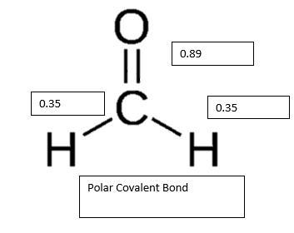

1.

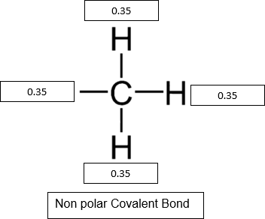2.

4.

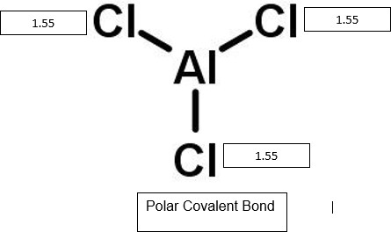

3.

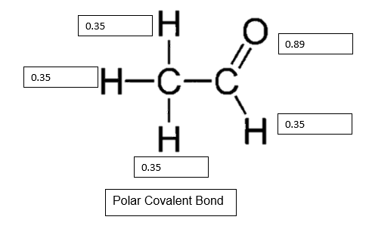





Activity No. 3

FBI (Figure out the Bonding)

Instruction: Complete the table and figure out the bond of the given compound.

|  |  |  |  |  |  |  |  |
| --- | --- | --- | --- | --- | --- | --- | --- |
| Compound | Melting point | Boiling point | Room temperature | Solubility | Electrical conductivity | Type of bond | Salt Name |
| 1.Cooking oil | High | High | Liquid | Not soluble in water | Not a good conductor of electricity | Covalent | N/A |
| 2.Salt (NaCl) | High | High | Solid | Soluble in water | Good conductor of electricity | Ionic | Sodium Chloride |
| 3. sugar | High | High | Solid | Soluble in water | Not a good conductor of electricity | Covalent | Sucrose |
| 4. vinegar | High | High | Liquid | Soluble in water | Good conductor of electricity | Covalent bond | Acetic Acid |

3.

